Day-2 (Assignment-2)

**ct**

.

ws

:



**Assignment 1:**



**SDLC Overview - Create a one-page infographic that outlines the SDLC phases (Requirements, Design, Implementation, Testing, Deployment), highlighting the importance of each phase and how they**

**interconne**

In the Software Development Life Cycle (SDLC), the various phases and their importance are as follo

* **Planning:** Importance: This phase lays the foundation for the entire project. Proper planning ensures that the project's objectives, scope, resources, timeline, and constraints are well-defined and understood by all stakeholders. Good planning helps mitigate risks and sets the project up for success.
* **Analysis: Importance**: During the analysis phase, the project requirements are gathered, analysed, and documented. This phase is crucial because it ensures that the development team has a clear understanding of what needs to be built, and it helps to identify potential issues or conflicts early on, preventing costly rework later in the project.
* **Design: Importance:** The design phase involves creating the overall architecture, user interface design, database design, and other technical specifications for the software. A well-designed system is easier to implement, maintain, and scale in the future.
* **Implementation: Importance**: This phase is where the actual coding and development of the software takes place. Proper implementation following best practices and coding standards ensures that the software is reliable, efficient, and maintainable.
* **Testing and Integration**: Importance: Testing is crucial for identifying and resolving defects, ensuring that the software meets the specified requirements, and verifying its quality. Integration testing ensures that the various components of the software work together seamlessly
* **Maintenance: Importance:** Once the software is deployed, maintenance is necessary to address bugs, implement enhancements, and adapt to changing requirements or environments. Proper maintenance ensures the software's continued functionality, performance, and relevance.

While all phases are important, the emphasis on each phase may vary depending on the project's complexity, the development methodology (e.g., Waterfall, Agile), and the specific requirements of the organization or industry. However, neglecting any phase can lead to issues such as incomplete or incorrect requirements, design flaws, implementation errors, quality issues, or maintenance challenges, ultimately impacting the success of the software project.

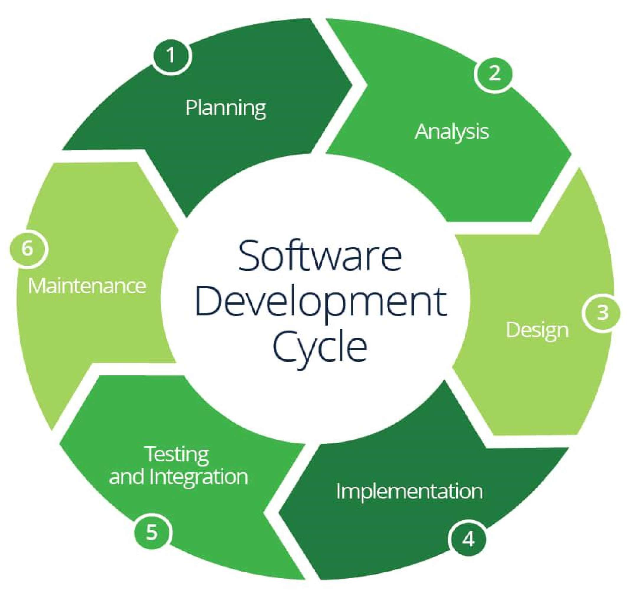

# Interconnection:

* + **Iterative Process:** Phases are interconnected and iterative, allowing for feedback and adjustments throughout the lifecycle.
  + **Collaboration**: Close collaboration among stakeholders, developers, testers, and users is essential for success.
  + **Continuous Improvement:** Learnings from each phase inform future iterations, driving continuous improvement.



**Assignment 2:**

**Develop a case study analysing the implementation of SDLC phases in a real-world engineering project. Evaluate how Requirement Gathering, Design, Implementation, Testing, Deployment, and Maintenance contribute**

**to project outcomes.**

**Implementation of SDLC Phases in a Real-World Engineering Project.**

**Project Overview**: Company Y, a multinational automotive manufacturer, embarked on a project to develop a next-generation electric vehicle (EV) targeting the consumer market. The project aimed to design and produce an EV that combines cutting-edge technology with sustainable and eco-friendly features.

**Requirement Gathering**: The project kicked off with a series of workshops involving cross- functional teams comprising engineers, designers, marketing specialists, and environmental experts. Stakeholders conducted market research, analysed consumer preferences, and identified regulatory requirements related to EVs. Key requirements included range, charging infrastructure compatibility, safety features, and aesthetic design.

**Outcome**: Comprehensive understanding of customer needs, market trends, and regulatory constraints, guiding the direction of the project.

**Design:** Based on the gathered requirements, the design phase commenced with the development of conceptual sketches, 3D models, and virtual prototypes. Engineers focused on optimizing the vehicle's aerodynamics, battery placement, and energy efficiency. Designers collaborated to create sleek and futuristic exterior designs while ensuring ergonomic and comfortable

interiors. Additionally, software architects designed onboard systems for vehicle control, entertainment, and connectivity.

**Outcome**: Detailed design blueprints and digital prototypes that translated stakeholder requirements into actionable development plans.

**Implementation**: The development team utilized a concurrent engineering approach to begin prototyping and manufacturing components while design work was ongoing. Advanced manufacturing techniques such as 3D printing and laser cutting were employed to accelerate the production process. Software developers worked in tandem to write code for the vehicle's embedded systems, including the battery management system, vehicle control unit, and infotainment system.

**Outcome**: Simultaneous progress in design and manufacturing, ensuring timely completion of the prototype vehicle.

**Testing**: A rigorous testing regimen was implemented to evaluate the performance, safety, and reliability of the EV prototype. Component-level testing included stress tests on batteries, durability tests on chassis components, and performance tests on electric motors. Integration testing was conducted to ensure seamless interaction between hardware and software subsystems. Extensive real-world testing was also performed, including road tests in various environmental conditions.

**Outcome**: Identification and resolution of design flaws and performance issues, ensuring the prototype meets quality and safety standards.

**Deployment**: Upon successful testing and validation of the prototype, the EV entered the production phase. Manufacturing facilities were retooled and production lines were optimized to accommodate the unique requirements of EV production. Supply chain partners were engaged to ensure a steady supply of components and materials. Initial production runs were closely monitored to identify and address any manufacturing defects or quality issues.

**Outcome**: Smooth transition from prototype to mass production, ensuring consistency and reliability in the manufactured vehicles.

**Maintenance**: Post-production, the engineering team continued to monitor field performance and gather feedback from customers. Software updates and improvements were rolled out periodically to enhance the vehicle's functionality and address any emerging issues. Customer support teams were

equipped to assist with technical inquiries and provide maintenance services, ensuring a positive ownership experience for EV owners.

**Outcome:** Continuous improvement and refinement of the EV based on real- world usage and customer feedback, fostering brand loyalty and long-term success.

**Conclusion:** By effectively implementing the SDLC phases, Company Y successfully developed and launched a groundbreaking electric vehicle that met consumer expectations for performance, safety, and sustainability.

Through meticulous requirement gathering, innovative design, efficient implementation, rigorous testing, seamless deployment, and proactive maintenance, the project achieved its objectives and established Company Y as a leader in the EV market.



**Assignment 3:**

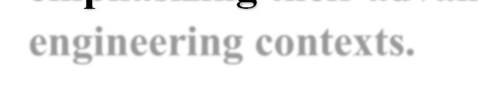

**Research and compare SDLC models suitable for engineering projects. Present findings on Waterfall, Agile, Spiral, and V-Model approaches, emphasizing their advantages, disadvantages, and applicability in different engineering contexts.**

The Software Development Life Cycle (SDLC) is a structured process that outlines the various stages involved in the development of a software system. There are several SDLC models, each with its own strengths, weaknesses, and suitability for different types of engineering projects. In this analysis, we will explore the Waterfall, Agile, Spiral, and V-Model approaches, highlighting their advantages, disadvantages, and applicability in different engineering contexts.

* **Waterfall Model:** The Waterfall model is a traditional, sequential approach to software development. It follows a linear progression through distinct phases: requirements gathering, design, implementation, testing, and maintenance.

# Advantages:

* Simple and easy to understand
* Well-defined stages and deliverables and suitable for projects with stable and well-documented requirements
* Easy to manage and monitor progress

# Disadvantages:

* Inflexible and rigid.
* Difficult to accommodate changes in requirements later in the project.
* No working software until the end of the development cycle.
* Inadequate for complex or rapidly changing projects.

**Applicability:** The Waterfall model is suitable for projects with well-defined and stable requirements, such as projects in areas like manufacturing, banking, or government sectors, where changes are infrequent and heavily regulated.

# Agile Model: Advantages:

* + **Flexibility:** Embraces change and allows for iterative development.
  + **Customer Collaboration:** Regular feedback from stakeholders ensures alignment with customer needs.
  + **Early Delivery:** Prioritizes delivering working software in short iterations.

# Disadvantages:

* + **Complexity:** Requires highly collaborative and self-organizing teams.
  + **Documentation:** May lack comprehensive documentation, leading to knowledge gaps.
  + **Scope Creep:** Continuous changes may lead to scope creep if not managed effectively.

**Applicability:** Ideal for projects with evolving requirements, where frequent delivery of usable increments is valued, and customer involvement is crucial throughout the development process.

# Spiral Model:

**Advantages:**

* + **Risk Management:** Emphasizes risk identification and mitigation throughout the project lifecycle.
  + **Flexibility:** Allows for iterative development and refinement of prototypes.
  + **Feedback Loop:** Incorporates customer feedback early and often, reducing the risk of late-stage changes.

# Disadvantages:

* + **Complexity:** Requires thorough risk analysis and management expertise.
  + **Resource Intensive:** Prototyping and iterations can consume time and resources.
  + **Suitability:** May not be suitable for small or straightforward projects due to its complexity.

**Applicability:** Well-suited for projects with high uncertainty and evolving requirements, where early identification and mitigation of risks are critical.

# 2. V-Model: Advantages:

* + **Traceability:** Emphasizes traceability between requirements and test cases.
  + **Early Testing:** Testing activities are initiated early in the development lifecycle.
  + **Structured Approach:** Provides a structured approach to software development and testing.

# Disadvantages:

* + **Rigidity:** Similar to Waterfall, changes late in the process can be costly and time- consuming.
  + **Documentation Overload:** Requires extensive documentation, which can be cumbersome.
  + **Sequential Nature:** Limited flexibility for iterative development and customer feedback.

**Applicability:** Suitable for projects with clear and stable requirements, where thorough testing and traceability are critical, and changes are minimal or well- controlled.

When selecting an SDLC model for an engineering project, it is crucial to consider factors such as project size, complexity, requirements volatility, team expertise, and the criticality of the system being developed. Each model has its strengths and weaknesses, and the choice should align with the project's specific needs and constraints. In some cases, a hybrid approach that combines elements of different models may be the most appropriate solution.

It is important to note that the effectiveness of any SDLC model ultimately depends on the team's ability to adapt and tailor the processes to their specific project needs, as well as their commitment to following best practices and maintaining open communication and collaboration throughout the development lifecycle.

